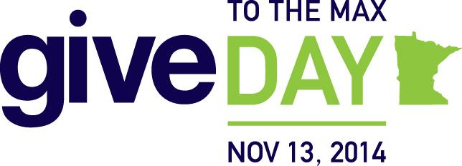
Dear Matoska Families,
What if you could turn a $10 donation into an additional $2,000 donation for Matoska International?
Join us on November 13, 2014, for Give to the Max Day – and you could help make that happen! Make your donation on GiveMN.org and help us continue to change lives at Matoska.
On November 13, every gift made on GiveMN.org will be entered into an hourly drawing for a $2,000 GiveMN Golden Ticket to be awarded to a Minnesota school. That adds up to 24 opportunities for you to help us receive an extra $2,000!
Here’s the really exciting part: At the end of Give to the Max Day, one donation made on GiveMN.org will be randomly selected to receive a $10,000 Super-Sized GiveMN Golden Ticket just for schools.
The more gifts we generate on GiveMN.org on November 13, the more our chances increase to receive that additional $20,000 donation. Imagine what we could do with $20,000!
Our goal is to raise $2000 in this 24 hour period and you can help us reach it! Your $10, $20 or even $30 gift can get us there.
Want to double your gifts? Check with your employer and find out how they will match your gift on Give to the Max Day!
Be sure to mark your calendar and make your gift on November 13 by visiting GiveMN.org and searching for our school.
Sincerely,
Matoska International PTO

